Talk to your classmates and find the missing sentences!
IT LOOKS LIKE A CHALLENGE!
Name: ___________
HR: _____________

My brother has a test today.  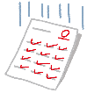  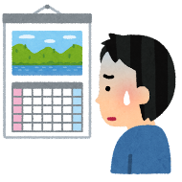 | He looks nervous.
My mother baked a cake.

Let’s watch this movie.

Did you go to bed late?
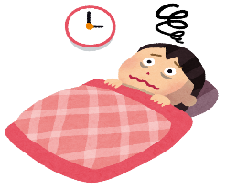

This is a picture of Kinkaku-Ji.

I like your new shoes.
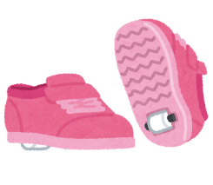

Can you write a sentence to match each picture?
Talk to your classmates and find the missing sentences!
IT LOOKS LIKE A CHALLENGE!
Name: ___________
HR: _____________

My brother has a test today.

My mother baked a cake. | It looks delicious.
Let’s watch this movie.

Did you go to bed late?

This is a picture of Kinkaku-Ji.

I like your new shoes.

Can you write a sentence to match each picture?
Talk to your classmates and find the missing sentences!
IT LOOKS LIKE A CHALLENGE!
Name: ___________
HR: _____________

My brother has a test today.

My mother baked a cake.

Let’s watch this movie. | It looks funny.
Did you go to bed late?

This is a picture of Kinkaku-Ji.

I like your new shoes.

Can you write a sentence to match each picture?
Talk to your classmates and find the missing sentences!
IT LOOKS LIKE A CHALLENGE!
Name: ___________
HR: _____________

My brother has a test today.

My mother baked a cake.

Let’s watch this movie.

Did you go to bed late? | You look tired.

This is a picture of Kinkaku-Ji.

I like your new shoes.

Can you write a sentence to match each picture?
Talk to your classmates and find the missing sentences!
IT LOOKS LIKE A CHALLENGE!
Name: ___________
HR: _____________

My brother has a test today.

My mother baked a cake.

Let’s watch this movie.

Did you go to bed late?

This is a picture of Kinkaku-Ji.
It looks wonderful.

I like your new shoes.

Can you write a sentence to match each picture?
Talk to your classmates and find the missing sentences!
IT LOOKS LIKE A CHALLENGE!
Name: ___________
HR: _____________

My brother has a test today.

My mother baked a cake.

Let’s watch this movie.

Did you go to bed late?

This is a picture of Kinkaku-Ji.

I like your new shoes. | They look cool.

Can you write a sentence to match each picture?

