ALT: Mr Keith

I like *okonomiyaki*.

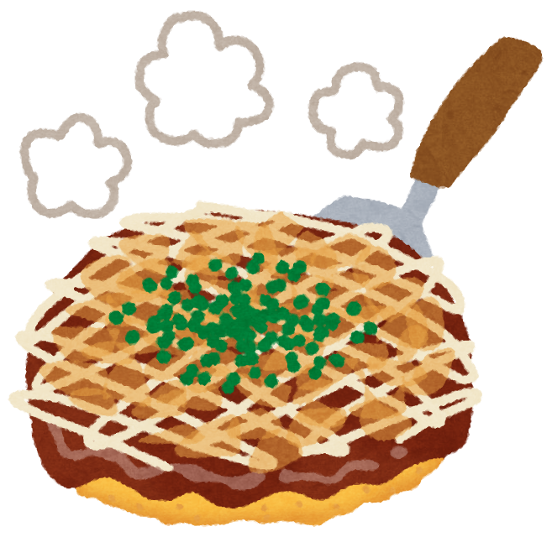

I’m from Australia.



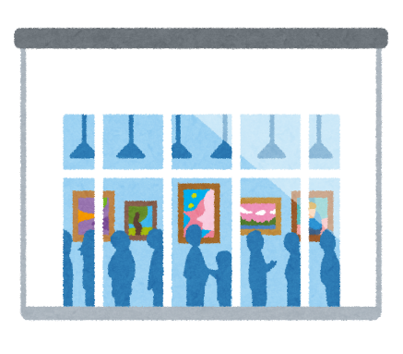

I like the museum.

I like orange.

Visit [www.worldtoiletday.info](http://www.worldtoiletday.info) & [www.worldtoiletday.jp](http://www.worldtoiletday.jp) to learn more.