A | C | Y | E | I | H | P | S | Q | S | S | A | B | A | E | S
G | A | S | J | S | J | 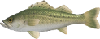  G | E | D | R | E | C | U | B | O | W
L | O | E | E | E | Y | D | A | W | B | A | S | C | N | S | T
P | K | A | B | A | B | N | B | M | F | B | E | V | M | E | D
Q | Z | B | G | B | B | W | A | L | S | A | T | S | A | A | V
I | N | A | C | A | S | A | S | Q | R | S | K | E | N | B | R
R | J | S | V | S | Y | V | S | Z | P | S | Q | A | U | A | S
S | G | S | T | S | F | S | E | S | D | E | U | B | T | S | S
M | E | W | F | U | F | J | S | G | K | O | R | A | C | S | A
Q | K | A | V | N | S | E | G | A | D | T | L | S | 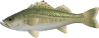  F | I | B
I | M | U | B | T | C | K | R | Y | B | H | G | S | B | C | A
S | E | A | B | A | S | S | S | L | P | A | I | B | H | Q | E
H | S | C | Z | G | S | I | B | A | G | O | E | G | J | D | S
L | B | A | N | K | U | S | G | V | J | F | W | S | W | M | P
☒ SEA BASS | スズキ | ☒ SEA BASS | 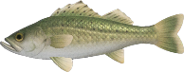  スズキ
☒ SEA BASS | スズキ | ☒ SEA BASS | スズキ
☒ SEA BASS | スズキ | ☒ SEA BASS | スズキ
☒ SEA BASS | スズキ | ☒ SEA BASS | スズキ
☒ SEA BASS | スズキ | ☒ SEA BASS | スズキ
☒ SEA BASS | スズキ | ☒ SEA BASS | スズキ
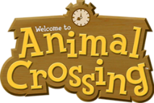
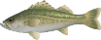
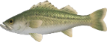
ワークシートにはシーバスが何匹いるでしょうか？
How many sea bass are there in this worksheet?
OH MY
GOD!
難易度:
?????
Word Search
オリジナルスタンプ
をゲット！

