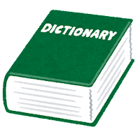

**Let’s make a dictionary quiz!**

2. word: ________________________________

definition: ___________________________________________

_______________________________________________________________________________________________________________________________________________________________

3. word: ________________________________

definition: ___________________________________________

_______________________________________________________________________________________________________________________________________________________________

**Find a word in the dictionary!**

1. word: ________________________________

definition: ___________________________________________

_______________________________________________________________________________________________________________________________________________________________