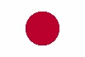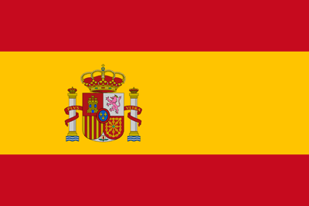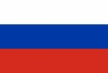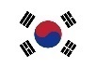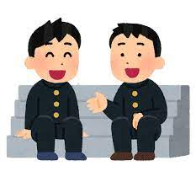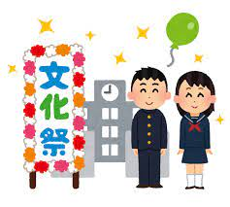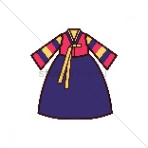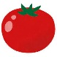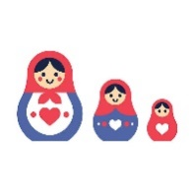

since last week

since ____ months ago

since junior high school

since I was a child

Japanese

Spanish

English

Korean

Russian  
________

a school festival

a tomato throwing festival

a downhill cheese race

traditional Korean clothes

a doll that goes inside other dolls

___________________________

It’s like… (6)

bunkasai

la tomatina

cheese rolling

hanbok

matryoshka

___________________

Have you ever heard of… (5)

______ weeks

______ months

a year

______ years

Lived here for? (3)

Japan

Spain

England

South Korea

Russia

_______

Country (1)

*You are meeting a foreign exchange student who is joining your class.*

A: Hello! Are you *name?*

B: Hi! Yes I am. Thank you for showing me around the school.

A: You’re welcome! How long have you been living in *Japan?* (1)

B: I have been living here for *three months.* (3) I have been studying *Japanese* (2) *since junior high school.* (4)

A: That’s great! Have you ever heard of *bunkasai?* (5)

B: No I haven’t, what is it?

A: It’s like *a school festival.*(6)It is part of our country’s culture. Anyway, class is about to start, so let’s go!

Studying since? (4)

こんにちわ！  
¡Hola!

Hello!

안녕하세요 annyeonghaseyo

Привет (privyet)

Language (2)