‘MAKES’ ACTIVITY
RULES: You are in groups. Look at the TV. Finish the sentence. If you guess the same as Miss D, you get extra points. Choose from the list below, or make your own!
PEOPLE | ADJECTIVES
Ironman | Happy
Mr Kumakura | Sad
Students | Excited
You | Angry
Satoshi (Ash) | Scared
Us | Thankful
Pikachu | Tired
Superman | Calm
Thanos | Strong
Harry Potter | Nervous
Ron Weasley | Cold
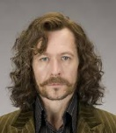  Sirius Black | Hot
Anya | Bored
Yor | Lazy
Miss D | Upset
Doraemon | Naughty
Spiderman | Confused
Dr Strange | Handsome
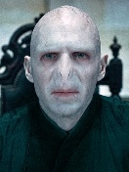  Voldemort | Light

KEY SENTENCE:
Playing sport makes me happy. (page 12)
Make your own sentences!
Example: Curry and rice makes Miss D happy.
- ____________________________________________________________________________________________________________________________________________
- ____________________________________________________________________________________________________________________________________________
- ____________________________________________________________________________________________________________________________________________
- ____________________________________________________________________________________________________________________________________________
- ____________________________________________________________________________________________________________________________________________
- ____________________________________________________________________________________________________________________________________________
- ____________________________________________________________________________________________________________________________________________
- ____________________________________________________________________________________________________________________________________________

