Hi, how are you?

I’m fine, thanks, and you?

I’m good, thanks.

Oh No! Where is my pen?

Here it is. It’s under the desk.

Oh, thank you.

Oh No! Where is my eraser?

Here it is. It’s by the blackboard.

Wow! Thank you!

Oh No! Where is my notebook?

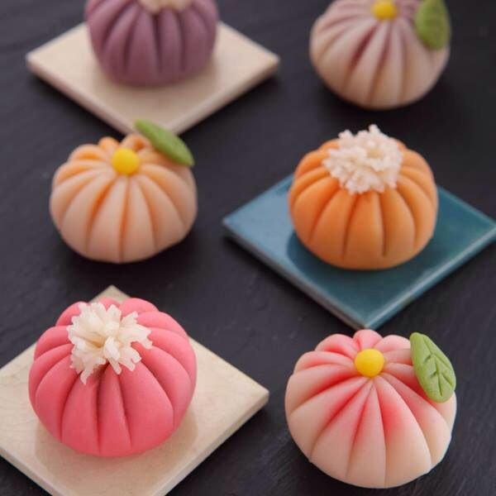
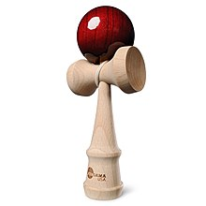
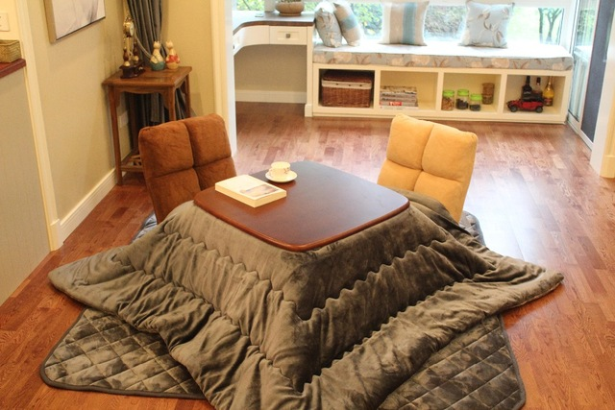
Here it is. It’s on your head.

