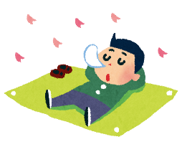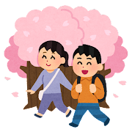

Name: ________________________________ Class: ___ - ___

How was your spring vacation?

1. **Where did you go?** (例: I **went to** Ueno Park in Tokyo)

＿＿＿＿＿＿＿＿＿＿＿＿＿＿＿＿＿＿＿＿＿＿＿＿＿＿＿＿＿＿＿＿.

1. **What did you eat?** (例: I **ate** mitarashi dango)

＿＿＿＿＿＿＿＿＿＿＿＿＿＿＿＿＿＿＿＿＿＿＿＿＿＿＿＿＿＿＿＿.

1. **What did you do?** (例: I **watched** the cherry blossoms)

＿＿＿＿＿＿＿＿＿＿＿＿＿＿＿＿＿＿＿＿＿＿＿＿＿＿＿＿＿＿＿＿.

1. **How was it?** (例: It **was** beautiful)

＿＿＿＿＿＿＿＿＿＿＿＿＿＿＿＿＿＿＿＿＿＿＿＿＿＿＿＿＿＿＿＿.



Name: ________________________________ Class: ___ - ___

How was your spring vacation?

1. **Where did you go?** (例: I **went to** Ueno Park in Tokyo)

＿＿＿＿＿＿＿＿＿＿＿＿＿＿＿＿＿＿＿＿＿＿＿＿＿＿＿＿＿＿＿＿.

1. **What did you eat?** (例: I **ate** mitarashi dango)

＿＿＿＿＿＿＿＿＿＿＿＿＿＿＿＿＿＿＿＿＿＿＿＿＿＿＿＿＿＿＿＿.

1. **What did you do?** (例: I **watched** the cherry blossoms)

＿＿＿＿＿＿＿＿＿＿＿＿＿＿＿＿＿＿＿＿＿＿＿＿＿＿＿＿＿＿＿＿.

1. **How was it?** (例: It **was** beautiful)

＿＿＿＿＿＿＿＿＿＿＿＿＿＿＿＿＿＿＿＿＿＿＿＿＿＿＿＿＿＿＿＿.