E | W | M | I | S | F | O | R | T | U | N | E | L | X | F | Y
H | I | W | G | I | C | L | F | I | N | G | E | R | H | D | V
I | T | F | J | Q | S | F | K | M | B | K | Q | J | V | M | R
P | A | N | D | A | D | O | I | S | X | R | A | P | I | C | G
J | D | Z | B | F | Q | B | E | G | O | J | O | U | C | U | R
C | O | A | P | L | I | F | K | U | H | N | V | N | Q | R | X
A | R | N | P | M | Y | K | D | G | Q | T | P | T | Q | S | I
D | I | C | U | B | A | U | H | C | V | J | N | O | H | E | H
X | B | U | R | J | Y | G | E | C | I | G | P | U | U | N | Y
T | E | S | I | X | T | I | Z | B | O | S | P | D | J | W | K
Y | X | K | F | F | U | S | H | I | G | U | R | O | W | R | X
Z | G | H | Y | F | Q | A | A | O | Z | M | V | U | L | R | P
Z | N | T | L | D | G | K | Y | S | O | R | C | E | R | Y | S
K | S | W | M | R | L | I | N | V | N | T | Q | O | T | Z | F
☐ ITADORI | 虎杖 | ☐ CURSE | 呪い
☐ GOJOU | 五条 | ☐ FINGER | 指
☐ KUGISAKI | 釘崎 | ☐ SORCERY | 呪術
☐ FUSHIGURO | 伏黒 | ☐ FIGHT | 廻戦
☐ TOUDOU | 東堂 | ☐ PURIFY | 祓う
☐ PANDA | パンダ | ☐ MISFORTUNE | 禍源；不運
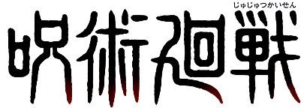
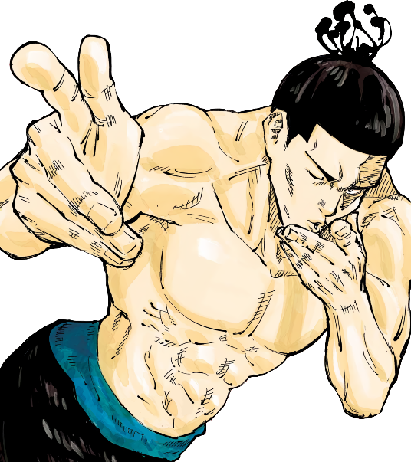
オリジナルスタンプ
をゲット！

HARD
難易度:
Word Search

