Hi, how are you?

I’m fine, thanks, and you?

I’m good, thanks.

I love quiz games!

Me too! Me too! Let’s play!

Four hints. One, its an animal. Two, it lives in Japan. Three, it can climb a tree and four it likes onsens.

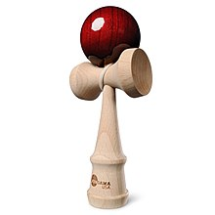
Hmmmm. Is it a monkey?

Yes, you got it. Your turn.

Ok. One, it’s an object. Two, its heavy. Three, it’s in the classroom, Four, It is dark green.

