（形容詞）
（動詞の原形）
It is ____________ to _______________.

1) In America, is it exciting to watch American football?
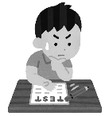
Yes, it is. / No, it isn’t.
2) In America, is it necessary to take a high school entrance exam?
Yes, it is. / No, it isn’t.
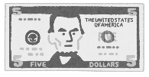
3) In America, is it common to pay with cash?
Yes, it is. / No, it isn’t.
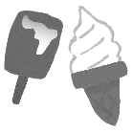
4) In American school, is it rare to have a locker?
Yes, it is. / No, it isn’t.
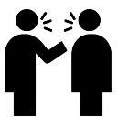
5) In America, is it common to start a conversation with strangers?
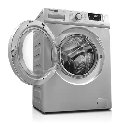
Yes, it is. / No, it isn’t.
6) In America, is it standard to have clothes dryers?
Yes, it is. / No, it isn’t.
7) In America, is it polite to slurp?
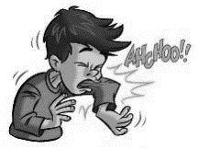
Yes, it is. / No, it isn’t.
8) In America, is it polite to say “Bless you,” when you sneeze?
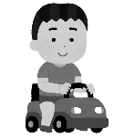
Yes, it is. / No, it isn’t.
9) In America, is it easy to go anywhere without a car?
Yes, it is. / No, it isn’t.
10) In America, is it expected to say the Pledge of Allegiance?
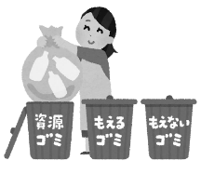
Yes, it is. / No, it isn’t.
11) In America, is it necessary to separate trash?
Yes, it is. / No, it isn’t.
12) In America, is it important to say “I love you,” to your family?
Yes, it is. / No, it isn’t.

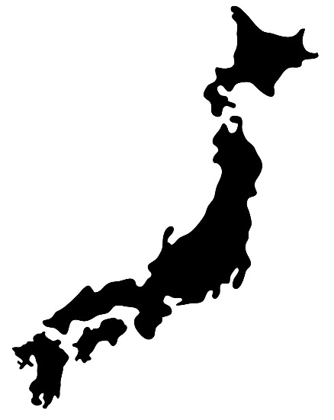
アメリカについて驚いたことは何ですか？
What surprised you about America?
______________________________________________________________________________________________________________________________________
Let’s introduce Japan!
In Japan, it is ________________________________ to _______________________________________________________________________________________.
In Japan, it is ________________________________ to _______________________________________________________________________________________.
In Japan, it is ________________________________ to _______________________________________________________________________________________.

exciting
common
rare
standard
easy
difficult
typical
わくわく
一般的
珍しい
標準
簡単
難しい
典型的
rude
polite
expected
important
necessary
unnecessary

無礼
丁寧
普通
大切
必要
不必要

