Name: ______________ Class: ____ Number: ____ Date: __/___
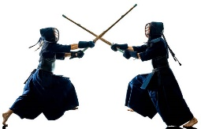
WE CALL THIS GAME CAT FUN TIME
- _________________________________________________________________
_________________________________________________________________
- _________________________________________________________________

 


