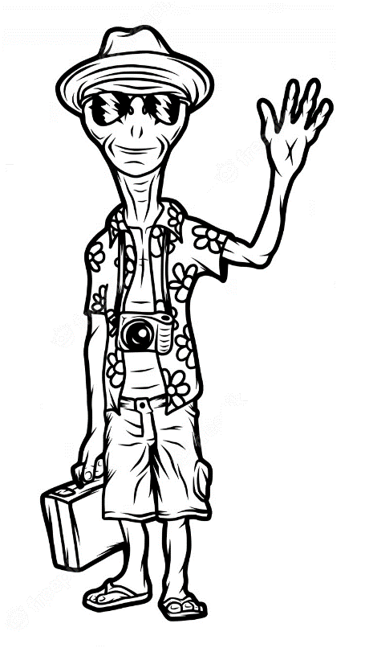
Hey! I’m Zeep. I want to visit Earth.
Can you teach me about humans?

Zeep is going to visit Earth, but he doesn’t know a lot about
humans. Can you help him learn about humans?

True or false:
- It is important for humans to drink cola every day. 〇 True 〇 False
- It is healthy for humans to eat fruit. 〇 True 〇 False.
- It is easy for humans to use a smartphone. 〇 True 〇 False
- It is difficult for humans to walk. 〇 True 〇 False
- It is possible for humans to breathe underwater. 〇 True 〇 False

Write your own:
- ______________________________________________________________________
- ______________________________________________________________________
- ______________________________________________________________________
dangerous 危ない (im)possible (不)可能 easy 簡単 necessary 必要
good いい・健康 (un)healthy (不)健康 boring 退屈 important 大事
bad 悪い・不健康 difficult/hard 難しい fun 楽しい tiring 疲れさせる

