Name: ___________________ Class: ____ Number: ____ Date: ___/___
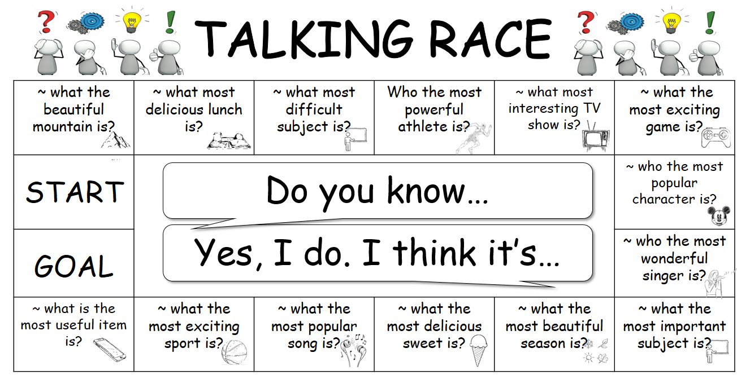

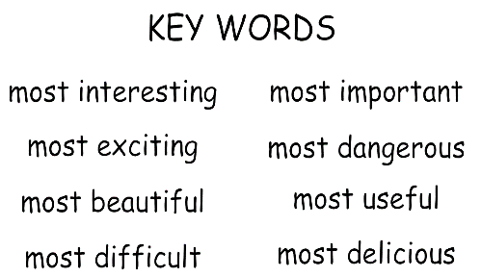
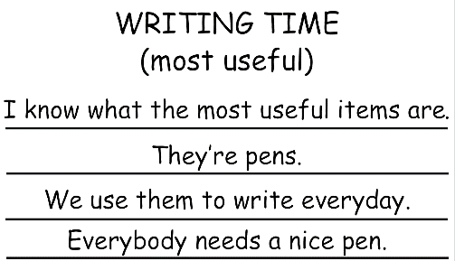
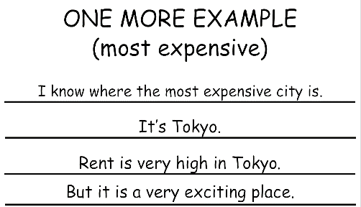
WRITING TIME

- __________________________________________________________________
__________________________________________________________________
__________________________________________________________________
__________________________________________________________________
- __________________________________________________________________
__________________________________________________________________
__________________________________________________________________
__________________________________________________________________
- __________________________________________________________________
__________________________________________________________________
__________________________________________________________________
__________________________________________________________________
- __________________________________________________________________
__________________________________________________________________
__________________________________________________________________
__________________________________________________________________

