Name: ______________ Class: ____ Number: ____ Date: ___/___

**THE FACE GAME**

**Round ONE**

|  |  |  |  |  |  |  |
| --- | --- | --- | --- | --- | --- | --- |
| 「bored clipart」の画像検索結果 | http://www2.edu.ipa.go.jp/gz/f-ccc1/f-cst1/f-ctb1/f-ctf1.jpg | 「thirsty」の画像検索結果 | http://www2.edu.ipa.go.jp/gz/f-ccc1/f-cst1/f-ctb1/f-cth1.jpg | 「nervous clipart」の画像検索結果 | http://www2.edu.ipa.go.jp/gz/f-ccc1/f-cst1/f-ctb1/f-cte1.jpg | http://www2.edu.ipa.go.jp/gz/f-ccc1/f-crk1/f-csb1/f-cse1.jpg |
| bored | sad | thirsty | tired | nervous | angry | hungry |
|  |  |  |  |  |  |  |

**Round TWO**

|  |  |  |  |  |  |  |
| --- | --- | --- | --- | --- | --- | --- |
| http://www2.edu.ipa.go.jp/gz/f-ccc1/f-crk1/f-csb1/f-csf1.jpg | 「excited clipart」の画像検索結果 | http://www2.edu.ipa.go.jp/gz/f-ccc1/f-cst1/f-ctk1/f-ctm1.jpg | http://www2.edu.ipa.go.jp/gz/f-ccc1/f-crk1/f-csb1/f-csc1.jpg | http://www2.edu.ipa.go.jp/gz/f-ccc1/f-cst1/f-ctk1/f-ctu1.jpg | 「happy clipart」の画像検索結果 | 「scared clipart」の画像検索結果 |
| sick | excited | cold | hot | sleepy | happy | scared |
|  |  |  |  |  |  |  |

**WRITING TIME**

1. When do you feel happy?

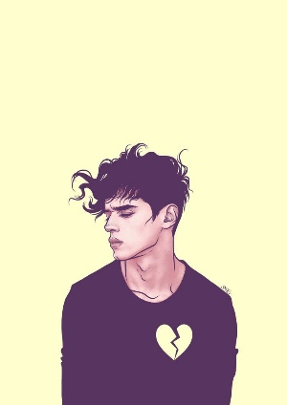________________________________________________________________

________________________________________________________________

1. Write about him.

_____________________________________________________

_____________________________________________________

1. When do you feel hungry?

________________________________________________________________

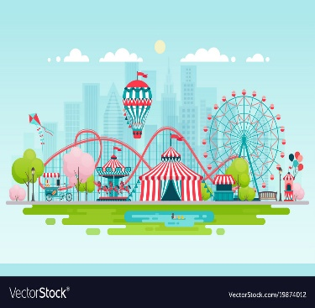________________________________________________________________

1. Write about it.

_____________________________________________________

_____________________________________________________

1. When do you feel ____________?

________________________________________________________________

________________________________________________________________