My favorite…

 | 日本語 | 英語
Anime
TV Show/Drama
Movie

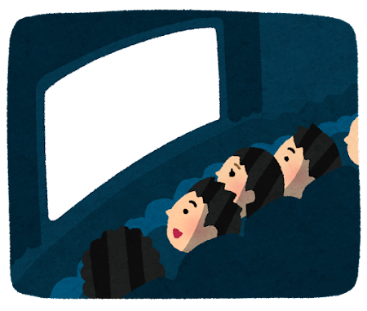
Quiz your classmates on the English name of your favorite anime, show, or movie!

Example: My favorite anime is 鬼滅の刃. What is the name in English?

Make up two FAKE English names and hide it with the REAL English name.

Example:
Demon Hunter
Monster Fighter
Demon Slayer (REAL!)

ENGLISH

Real name: _______________________________________
Fake name #1: ____________________________________
Fake name #2: ____________________________________

