Choose from the box and write the name of the country.
- ________________________
- 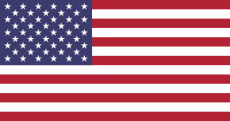 ________________________

- ________________________
- 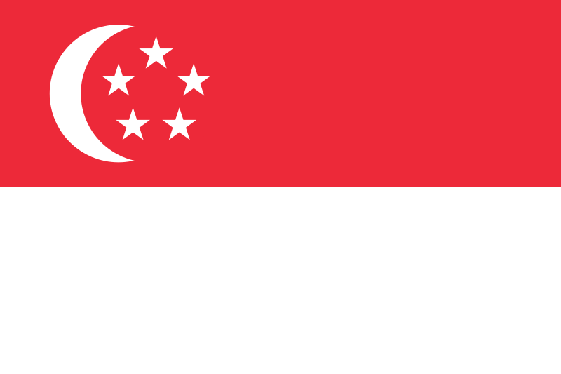 ________________________
Korea France Canada Italy
America Singapore Jamaica UK Thailand

- _______________________
- _______________________
- ______________________
- ______________________

You can choose from the boxes and fill in the blank lines.

- Which country do you want to visit？
I want to visit ______________________________________
2. Why do you want to go there？
I want to eat _____________________________________
Pasta Hamburger Maple Syrup Bibimbap Curry Rice
Pizza Kimchi Poutine Curry Rice Fish and Chips

I want to see ______________________________________________
beautiful views exotic animals historic buildings
foreign people foreign culture historic ruins

I want to go to ____________________________________________
Whistler Grand Canal Big Ben Lotte World
Niagara Falls N Seoul Tower Singapore Flyer

I want to _____________________________________________
go shopping go sightseeing meet new people
go swimming go up a mountain go dancing

Practice conversation and write your partner’s response on the line.
A: Which country do you want to visit？
B: I want to visit ______________________________________.
A: Wow! That’s amazing. What do you want to eat there？
B: I want to eat______________________________________
A: Delicious! What do you want to see there？
B: I want to see _______________________________________
A: Where do you want to go there？
B: I want to go to _____________________________________
A: Interesting! What do you want to do there？
B: I want to ___________________________________________
and _______________________________________________

