

**. . . .**

**Dots & Boxes**

How to Play

|  |  |  |
| --- | --- | --- |
| Round | Points | メダル風王冠の白黒イラスト | 無料フリーイラスト素材集【Frame illust】**Winner** |
| 1 | **Player 1:** ___(点)  **Player 2:** ___(点) | **Player 1**  **Player 2** |
| 2 | **Player 1:** _____  **Player 2:** _____ | **Player 1**  **Player 2** |
| 3 | **Player 1:** _____  **Player 2:** _____ | **Player 1**  **Player 2** |
| 4 | **Player 1:** _____  **Player 2:** _____ | **Player 1**  **Player 2** |
| 5 | **Player 1:** _____  **Player 2:** _____ | **Player 1**  **Player 2** |

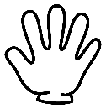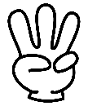鉛筆の無料イラスト | フリーイラスト素材集 ジャパクリップ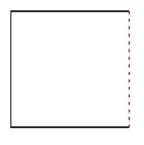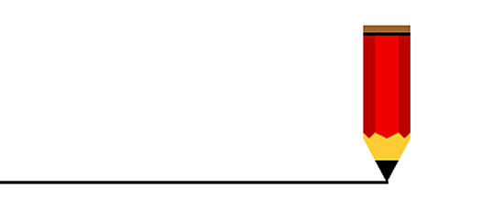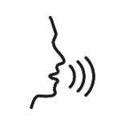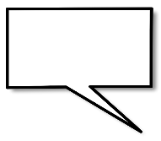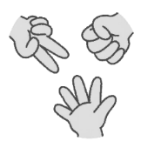

**= -1**

**= +2**

**= +3**

**= +5**

How to WIN

The player with the most squares wins!  
最も多くの四角を獲得したプレイヤーが勝ちです！

ROUND 1

**Player 1:** |||||||||||||||| **Player 2:** ||||||||||||||||

**Score Tracker**

**=**

- No diagonal lines.  
(ななめを書いてはいけません。)  
- Colour in your square.  
(四角が完成したら中に色をぬってね！)  
- If you complete a square, you can draw one more line!  
(四角が1つ完成したら、もう一本線を書くことができる！)

Make many  
squares!

5.

Draw a  
line!

4.

3.

Make a

Sentence!

[例] I like dogs.

RULES

Rock,

Paper

Scissors!

Choose

a

colour!

2.

1.