Hi, how are you?

I’m fine, thanks, and you?

I’m good, thanks.

What did you do on Sunday?

I went to the Niigata.

Nice. What did you do there?

I went shopping. I bought a jacket.

Cool. Did you eat lunch there?

Yes, I did. I went to Kappazushi.

I love Kappazushi. I like the hamburger sushi.

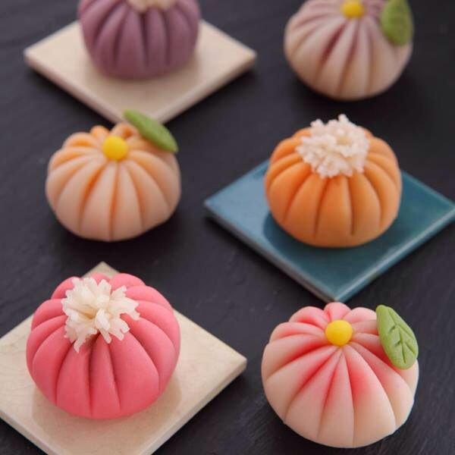
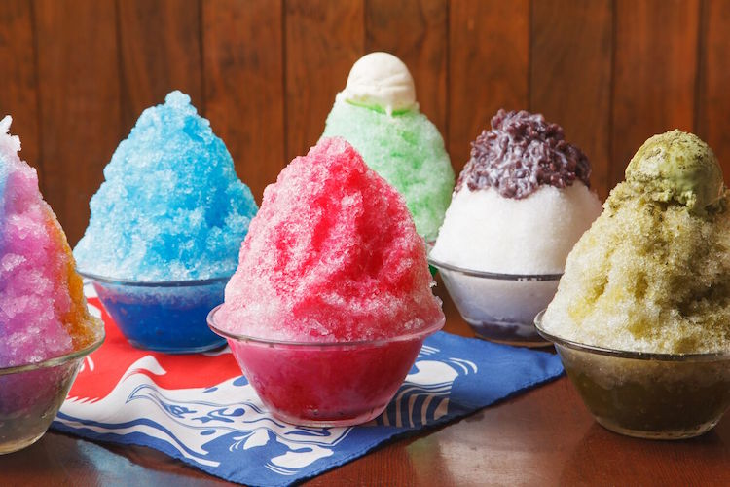
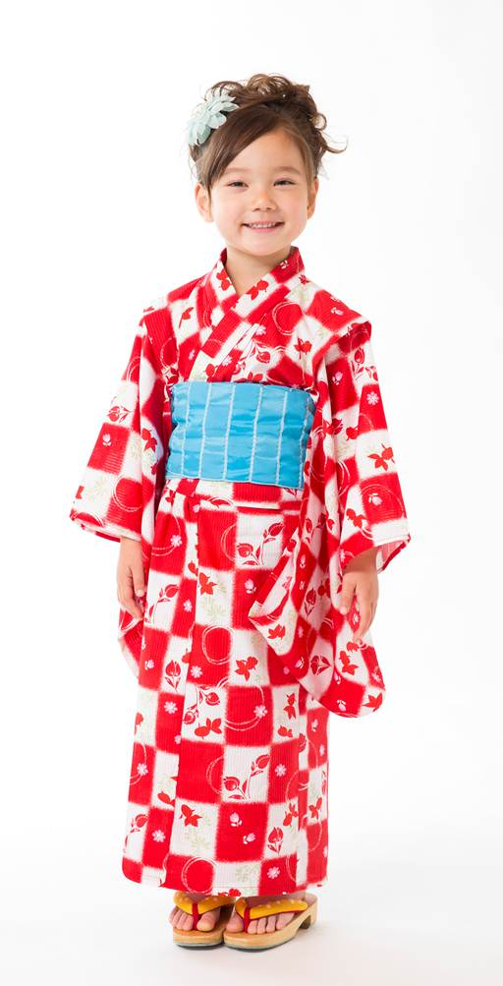
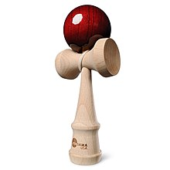
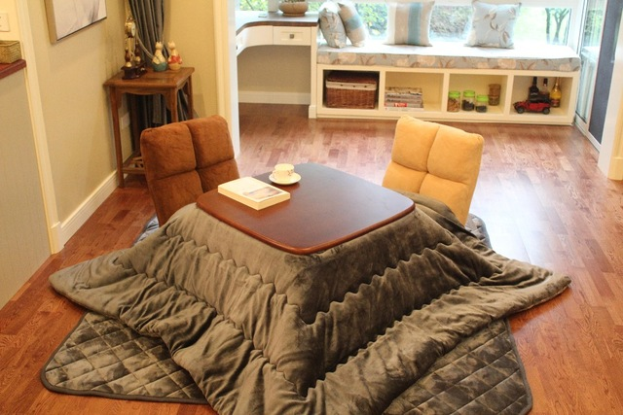
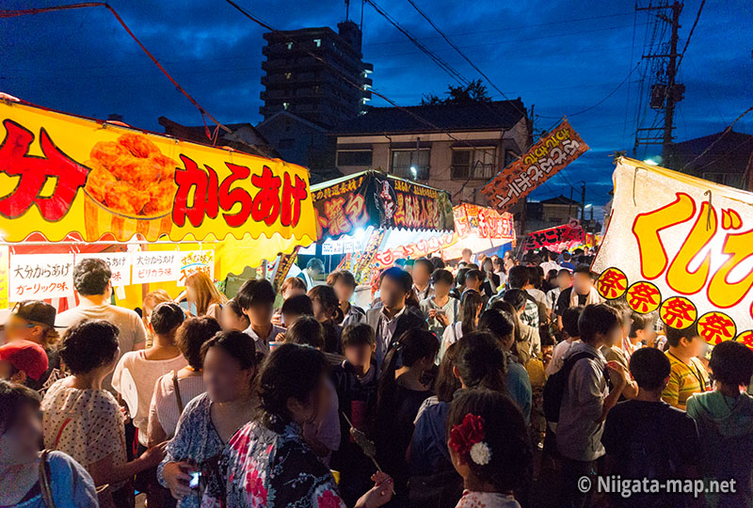
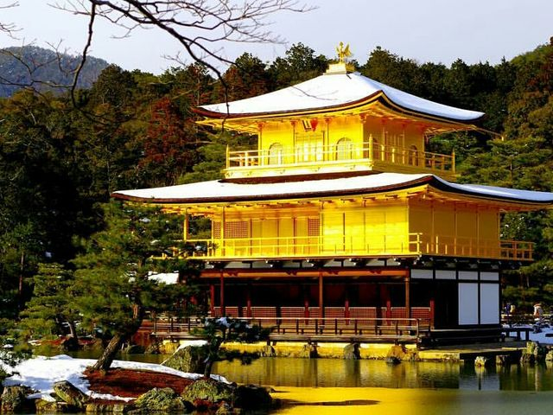
Me too!

