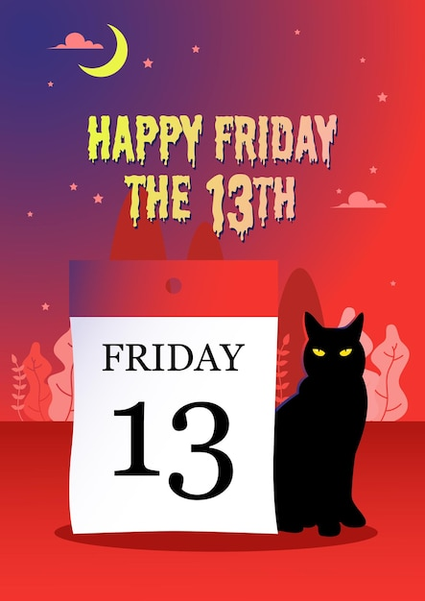

In Japan, the numbers 4 and 9 are unlucky, but in America, the number 13 is unlucky! When it’s the 13th and the day is a Friday, many Americans feel nervous. We call it Friday the 13th. It is a very spooky and unlucky day in America! There is a famous horror movie called Friday the 13th.

