2 Pencil 2 | 2 Pencil 2 | 2 Pencil 2 | 2 Pencil 2
2 Pencil 2 | 2 Pencil 2 | 2 Pencil 2 | 2 Pencil 2
2 Pencil 2 | 2 Pencil 2 | 2 Pencil 2 | 2 Pencil 2
2 Pencil 2 | 2 Pencil 2 | 2 Pencil 2 | 2 Pencil 2
2 Pencil 2 | 2 Pencil 2 | 2 Pencil 2 | 2 Pencil 2
2 Pencil 2 | 2 Pencil 2 | 2 Pencil 2 | 2 Pencil 2
2 Pencil 2 | 2 Pencil 2 | 2 Pencil 2 | 2 Pencil 2
2 Pencil 2 | 2 Pencil 2 | 2 Pencil 2 | 2 Pencil 2
2 Pencil 2 | 2 Pencil 2 | 2 Pencil 2 | 2 Pencil 2
2 Pencil 2 | 2 Pencil 2 | 2 Pencil 2 | 2 Pencil 2
2 Pencil 2 | 2 Pencil 2 | 2 Pencil 2 | 2 Pencil 2
2 Pencil 2 | 2 Pencil 2 | 2 Pencil 2 | 2 Pencil 2
2 Pencil 2 | 2 Pencil 2 | 2 Pencil 2 | 2 Pencil 2
2 Pencil 2 | 2 Pencil 2 | 2 Pencil 2 | 2 Pencil 2
2 Pencil 2 | 2 Pencil 2 | 2 Pencil 2 | 2 Pencil 2
2 Pencil 2 | 2 Pencil 2 | 2 Pencil 2 | 2 Pencil 2
2 Pencil 2 | 2 Pencil 2 | 2 Pencil 2 | 2 Pencil 2
2 Pencil 2 | 2 Pencil 2 | 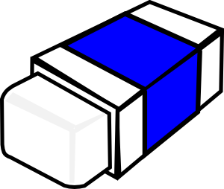  3 Eraser 2 | 3 Eraser 2
3 Eraser 2 | 3 Eraser 2 | 3 Eraser 2 | 3 Eraser 2
3 Eraser 2 | 3 Eraser 2 | 3 Eraser 2 | 3 Eraser 2
3 Eraser 2 | 3 Eraser 2 | 3 Eraser 2 | 3 Eraser 2
3 Eraser 2 | 3 Eraser 2 | 3 Eraser 2 | 3 Eraser 2
3 Eraser 2 | 3 Eraser 2 | 3 Eraser 2 | 3 Eraser 2
3 Eraser 2 | 3 Eraser 2 | 3 Eraser 2 | 3 Eraser 2
3 Eraser 2 | 3 Eraser 2 | 3 Eraser 2 | 3 Eraser 2
3 Eraser 2 | 3 Eraser 2 | 3 Eraser 2 | 3 Eraser 2
3 Eraser 2 | 3 Eraser 2 | 3 Eraser 2 | 3 Eraser 2
3 Eraser 2 | 3 Eraser 2 | 3 Eraser 2 | 3 Eraser 2
3 Eraser 2 | 3 Eraser 2 | 3 Eraser 2 | 3 Eraser 2
3 Eraser 2 | 3 Eraser 2 | 3 Eraser 2 | 3 Eraser 2
3 Eraser 2 | 3 Eraser 2 | 3 Eraser 2 | 3 Eraser 2
3 Eraser 2 | 3 Eraser 2 | 3 Eraser 2 | 3 Eraser 2
3 Eraser 2 | 3 Eraser 2 | 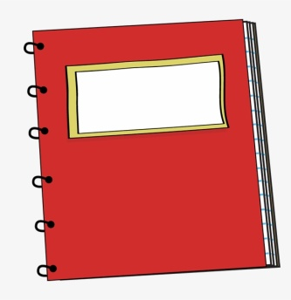  4 Notebook 3 | 4 Notebook 3
4 Notebook 3 | 4 Notebook 3 | 4 Notebook 3 | 4 Notebook 3
4 Notebook 3 | 4 Notebook 3 | 4 Notebook 3 | 4 Notebook 3
4 Notebook 3 | 4 Notebook 3 | 4 Notebook 3 | 4 Notebook 3
4 Notebook 3 | 4 Notebook 3 | 4 Notebook 3 | 4 Notebook 3
4 Notebook 3 | 4 Notebook 3 | 4 Notebook 3 | 4 Notebook 3
4 Notebook 3 | 4 Notebook 3 | 4 Notebook 3 | 4 Notebook 3
4 Notebook 3 | 4 Notebook 3 | 4 Notebook 3 | 4 Notebook 3
4 Notebook 3 | 4 Notebook 3 | 4 Notebook 3 | 4 Notebook 3
4 Notebook 3 | 4 Notebook 3 | 4 Notebook 3 | 4 Notebook 3
4 Notebook 3 | 4 Notebook 3 | 5 Lunchbox 4 | 5 Lunchbox 4
5 Lunchbox 4 | 5 Lunchbox 4 | 5 Lunchbox 4 | 5 Lunchbox 4
5 Lunchbox 4 | 5 Lunchbox 4 | 5 Lunchbox 4 | 5 Lunchbox 4
5 Lunchbox 4 | 5 Lunchbox 4 | 5 Lunchbox 4 | 5 Lunchbox 4
5 Lunchbox 4 | 5 Lunchbox 4 | 5 Lunchbox 4 | 5 Lunchbox 4
5 Lunchbox 4 | 5 Lunchbox 4 | 5 Lunchbox 4 | 5 Lunchbox 4
5 Lunchbox 4 | 5 Lunchbox 4 | 5 Lunchbox 4 | 5 Lunchbox 4
5 Lunchbox 4 | 5 Lunchbox 4 | 5 Lunchbox 4 | 5 Lunchbox 4
10 彼女 | 10 彼氏 | 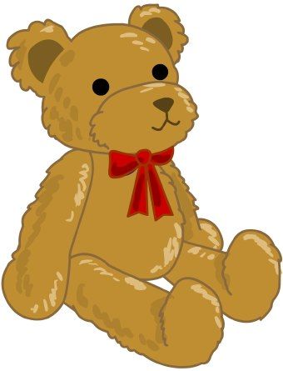  12ぬいぐるみ | 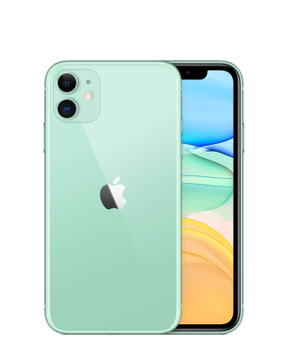  13携帯
10 彼女 | 10 彼氏 | 12ぬいぐるみ | 13携帯
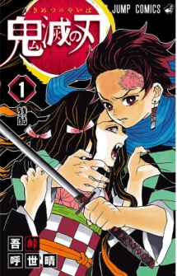  15 Manga | 15 Manga | 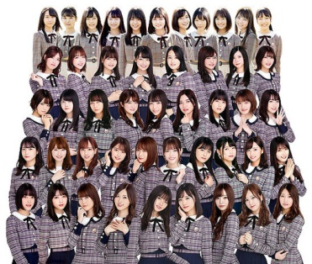  17Nogizaka46 | 17 BTS

