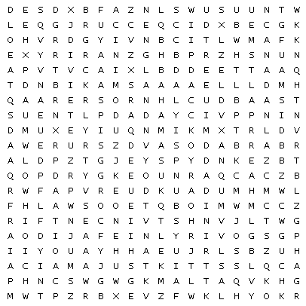

|  |  |  |  |  |  |  |  |  |  |  |  |  |  |  |  |  |  |  |  |  |  |  |  |  |  |  |
| --- | --- | --- | --- | --- | --- | --- | --- | --- | --- | --- | --- | --- | --- | --- | --- | --- | --- | --- | --- | --- | --- | --- | --- | --- | --- | --- |
| |  |  | | --- | --- | | America | Antigua | | Australia | Bahamas | | Barbados | Belize | | Canada | Dominica | | England | Grenada | | Guyana | Ireland | | Jamaica | Malta | | New Zealand | St Kitts | | St Lucia | St Vincent | | Trinidad |  | |  |  |  |  |  |  |
|  | |  |  |  |  |  |
|  | |  |  |  |  |  |
|  | |  |  |  |  |  |
|  | |  |  |  |  |  |
|  | |  |  |  |  |  |
|  | |  |  |  |  |  |