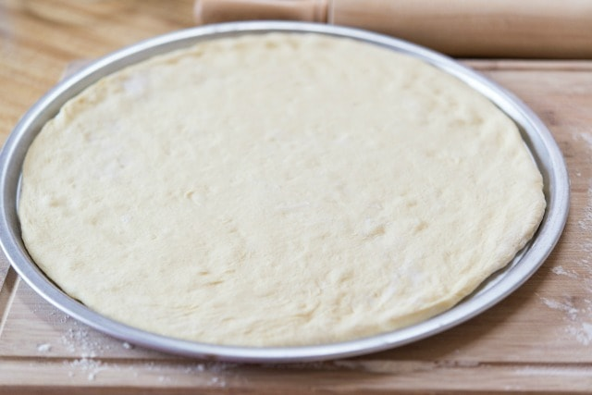lets make a pizza Name::___________ class: _______