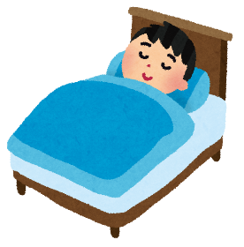
Examples:
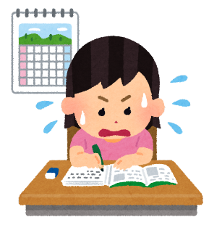
Have = you (or they)
Question: Have you finished your homework yet?
I have (or They have)
O Answer: I have just finished my homework.
O Answer: I have already finished my homework.
X Answer: I have not finished my homework yet.
Has = she (or he)
Question: Has she finished her homework yet?
She has (or He has)
O Answer: She has just finished her homework.
O Answer: She has already finished her homework.
X Answer: She has not finished her homework yet.

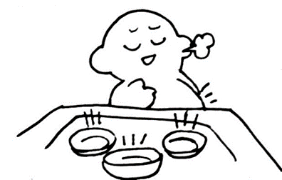
Make a sentence using the picture:

Question: _________________________________________________________________________________________

Answer: ________________________________________________________________________________________
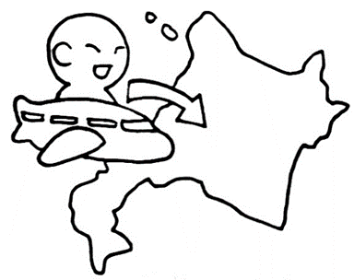
Question: _________________________________________________________________________________________

Answer: ________________________________________________________________________________________

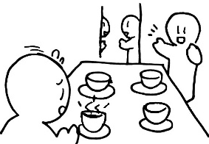
Question: _________________________________________________________________________________________

Answer: ________________________________________________________________________________________

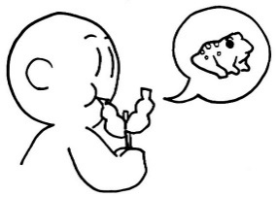
Question: _________________________________________________________________________________________

Answer: ________________________________________________________________________________________
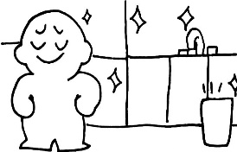
Question: _________________________________________________________________________________________

Answer: ________________________________________________________________________________________
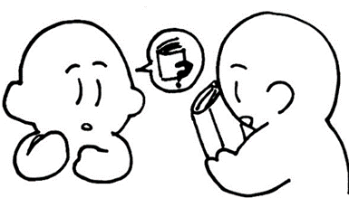
Question: _________________________________________________________________________________________

Answer: ________________________________________________________________________________________
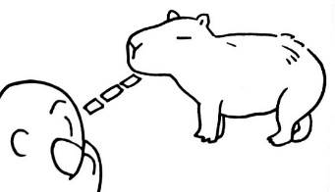
Question: _________________________________________________________________________________________

Answer: ________________________________________________________________________________________

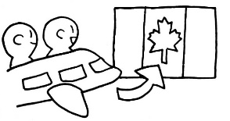
Question: _________________________________________________________________________________________

Answer: ________________________________________________________________________________________
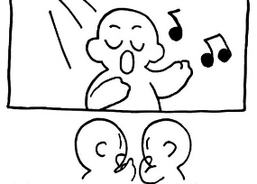
Question: _________________________________________________________________________________________

Answer: ________________________________________________________________________________________

Make an original sentence and draw a picture!

Question: _________________________________________________________________________________________

Answer: ________________________________________________________________________________________

