Make your own Ramen!
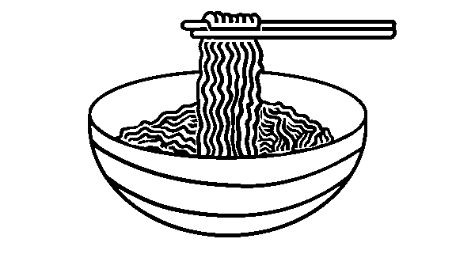

- How many fish cakes do you want?
I want ___ fish (cake / cakes).
- How many pork slices do you want?
I want ___ pork (slice / slices).
- How many shrimps do you want?
I want ___ (shrimp / shrimps).
- How many green onions do you want?
I want ___ green (onion / onions).
- How many seaweed sheets do you want?
I want ___ seaweed (sheet / sheets).
- How many corn kernels do you want?
I want ___ corn (kernel / kernels).

