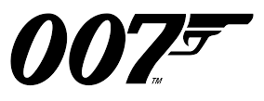
Worldwide Spies!
Key Questions
Do you know where ________________ is?
Do you know what _________________ is?
Could you tell me how to spell it?

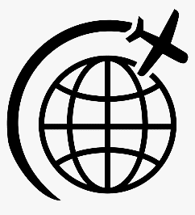
- Lima is in ____________________.
リマ
- The most popular sport in Russia is __________________.
ロシア
- Warsaw is in ___________________.
ウォーサー
- The smallest country in Africa is ________________.
アフリカ
- The longest river in Europe is the ___________________.
ヨーロッパ
川
- Nairobi is in ____________________.
ナイロビ
- The biggest city in California is _______________________.
- Kabul is in _________________.
カブール
- The most famous place in France is the ______________________.

SECRET CODE: (質問番号–文字番号)
スパイ行為 ＝ ____ ____ ____ ____ ____ ____ ____ ____ ____
(9-1)
(8-3)
(7-4)
(6-3)
(5-2)
(4-5)
(3-1)
(2-1)
(1-2)
ANSWERS
- PERU
- SOCCER
- POLAND
- GAMBIA
- VOLGA
- KENYA
- LOS ANGELES
- AFGHANISTAN
- EIFFEL TOWER
Code: E S P I O N A G E

