Name:________________________ Class:________ Date:________
Let`s plan a trip!
例) A: If you went to France, where would you visit?
B: I would visit the Eiffel tower.
 | eat (food) | meet (person) | see (animal) | 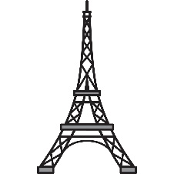  visit (place)
Country:
Name
Answer
Name
Answer
結果を書きましょう。
- If Sam went to Canada, he would eat maple syrup.

1. _____________________________________________________________________________________
2. _____________________________________________________________________________________
3. _____________________________________________________________________________________
4. _____________________________________________________________________________________
5. _____________________________________________________________________________________

