|  |
| --- |
|  |

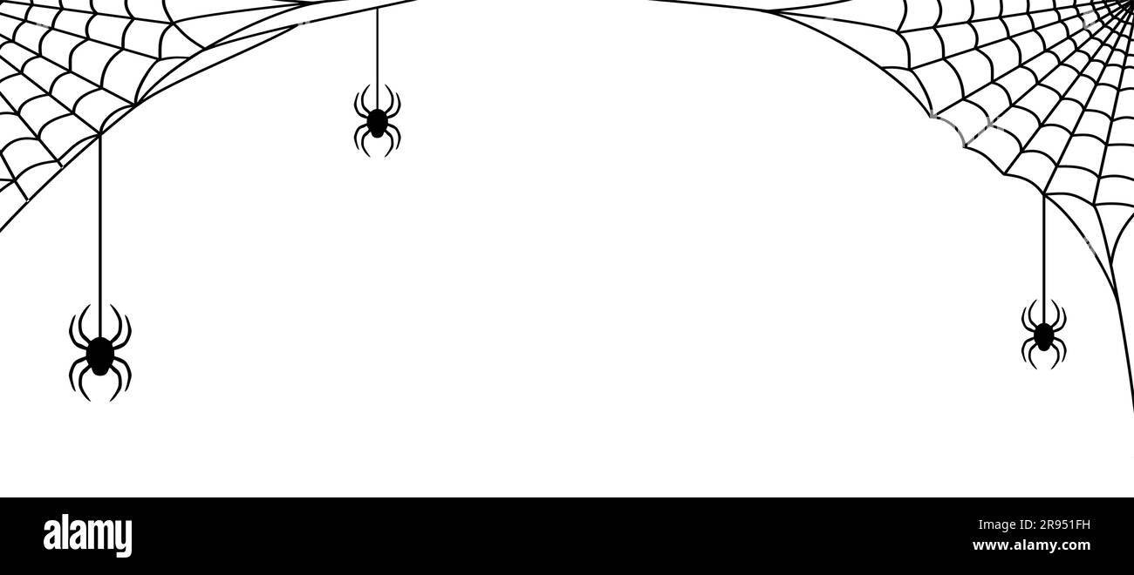**Let’s draw a halloween picture!**

