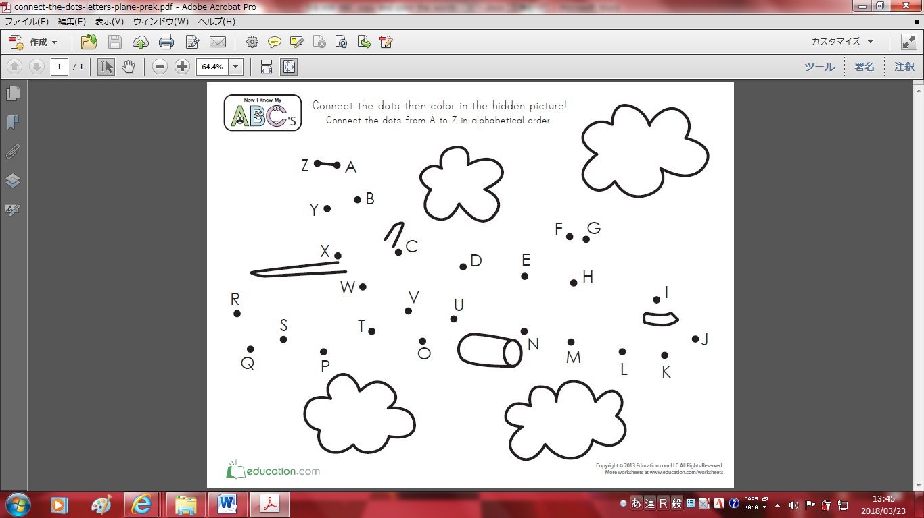

Name/名前: ________________

