PANDORA’S BOX
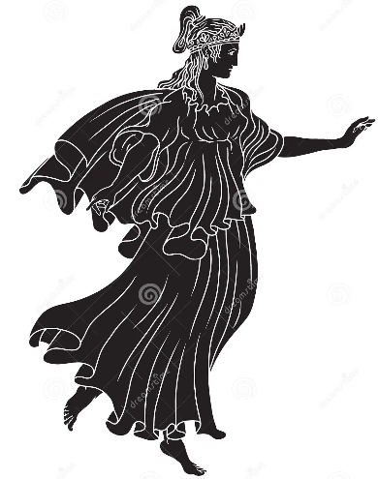
Long ago, on Mount Olympus, the gods enjoyed life. One day, the gods created a beautiful woman called Pandora.

Epimetheus, fell in love with Pandora and decided to marry her. One day, a god named Mercury gave them a box. He said, “Don’t open the box!”

Pandora wanted to see what was in the box because she thought the box had treasure in it. So, she opened the box and disease, sadness and death came out of the box.

QUESTION #1:

Why did Pandora open the box?

QUESTION #2:

Do you want to look in a mystery box? Why?

