Name: ___________________
This is a psychology test. Write your answer.
Don`t think about it, just write!

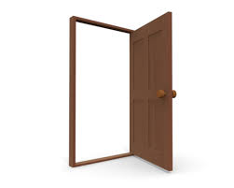
- You can see a door near you.
When you open the door, someone is standing there.
Who is it?

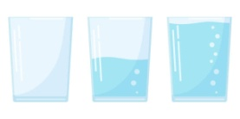
- You have a glass. When you put some water in it, how much water do you put?

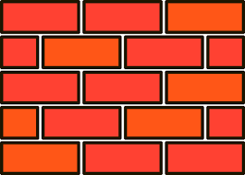
- When you are walking along a dark road, you find a wall. How tall is it?

- When you are watching 10 birds in a tree, some of them fly away.
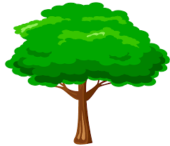
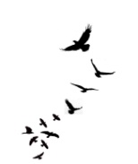
How many birds fly away?

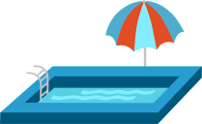
- When you swim, which do you choose, a pool or the sea?

- When you are looking out of your room, someone is looking at you.
How old are they?

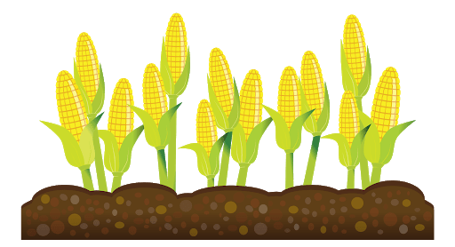
- You are in a desert. When you need food, what will you grow?
A: Carrots B: Cabbage C: Rice

- Someone you don`t want to meet. (会いたくない人)
- Your frustration. フラストレーション/ストレス
- Your pride. 自慢
- The number of people you disappointed in love.
あなたが恋に失望した人の数
- How you want to love: The pool = stable love 安定した愛
The sea = impulsive love
衝動的な愛 (しょうどうてきなあい)
- Your mental age.
- A. Carrot = you can be kind to everyone.
誰にでも新設にすることができる
B. Cabbage = you can be kind to just your friends.
友達だけに新設にすることができる
C. Rice = you are a self centered person.
あなたは自己中心的 (じこちゅうしんてき)

