Name: ________________ Number: _____________ Class: _________

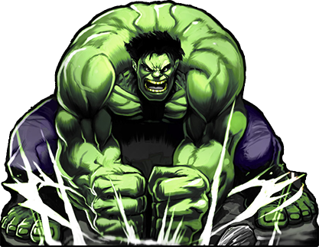

2Nd Year Version
on the table | green | saw | at school
sea turtles | Yes, there are | Uluru | No, we don’t.
In America | It’s an eraser | going to | iPhone
dancing | piano | 19th | there are two
Yes, I did. | Yes, I will. | pizza | On Sunday
Kimetsu no Yaiba | No, there aren’t | played | No, I won’t.
No, I’m not. | Yes, she can. | soccer | zoo
WRITE FOUR QUESTIONS
- __________________________________________________________________
- __________________________________________________________________
- __________________________________________________________________
- __________________________________________________________________

