Name: ______________ Class: ______ Number: _____

OUR ROOM (add 10 details)

|  |  |  |
| --- | --- | --- |
| in the sky  in the car  on the unicycle  on the road | on the wall  under the clock  on the sofa  in the bath | on the bench  under the desk  in the bowl  on the chair |

[Image result for drawing of a shooting star](https://www.google.co.jp/url?sa=i&rct=j&q=&esrc=s&source=images&cd=&ved=2ahUKEwiW_8m8zYvlAhV_yIsBHcPFBNsQjRx6BAgBEAQ&url=https%3A%2F%2Fwww.vectorstock.com%2Froyalty-free-vectors%2Fline-drawing-shooting-star-vectors&psig=AOvVaw0t6Nqec6PQLH-EC-dmacYP&ust=1570587747508032)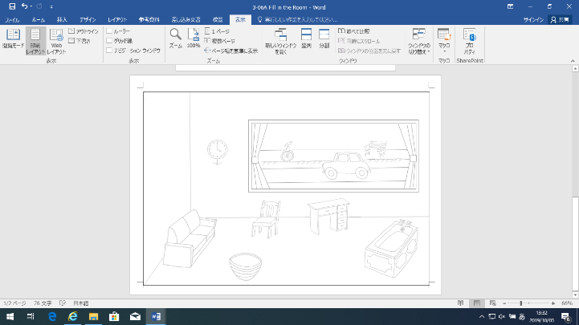There is a penguin sitting on the sofa.

Image result for drawing of a penguinThere are three stars flying in the sky.

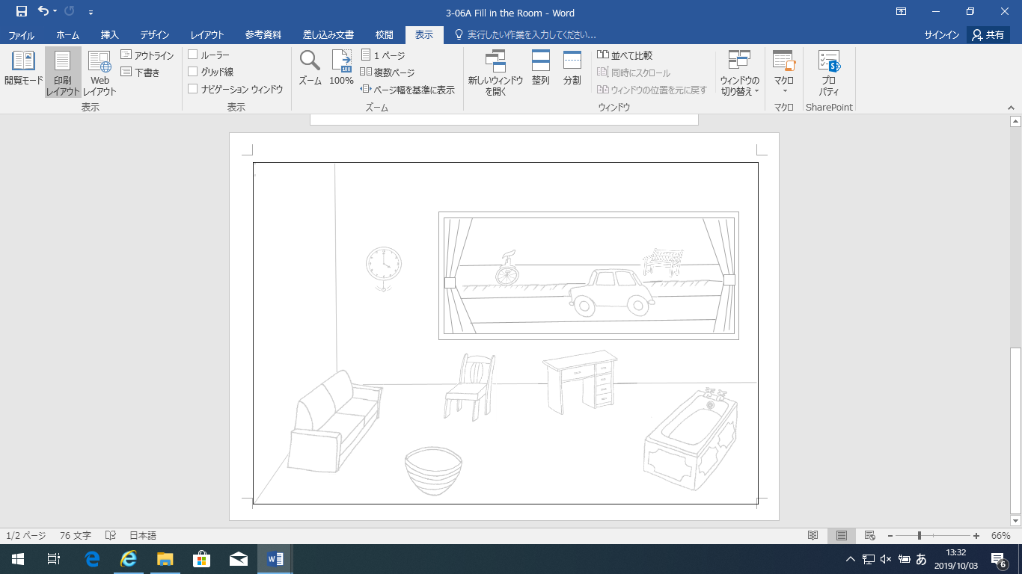

WRITE ABOUT YOUR PICTURE

1. ___________________________________________________
2. ___________________________________________________
3. ___________________________________________________
4. ___________________________________________________

