What do you want for Christmas？
Example: I want the iPhone 14 for Christmas. It`s the latest iPhone.
- I want ___________________________for Christmas. __________________________________
- ___________________________________________________________________________
- ___________________________________________________________________________ 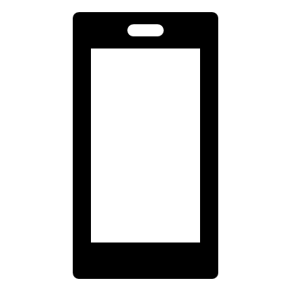

Share with your friends!
Example A: What do you want for Christmas？
B: I want new shoes for Christmas. I lost my shoes at school.
Santa will give you ￥30,000 to buy Christmas gifts for your friends.
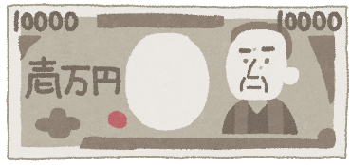
Example: I`ll give Aimi a new manga. She likes reading.
- I`ll give____________________________________. He/She________________________
- __________________________________________________________________________
- __________________________________________________________________________

