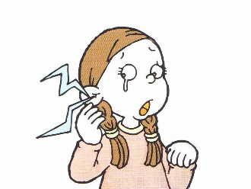
Name: _______________ Class: ____ Number: ___ Date: __/__
What’s wrong?
Doctor! Doctor!
Ouch! Ouch!
a stomachache
Yes, that’s right.
I see. Do you have an earache?
ASKING FOR HELP
a headache  Sign: | a toothache  Sign: | a stomachache  Sign:
a backache  Sign: | a sore throat  Sign: | a fever  Sign:
a cough  Sign: | a runny nose  Sign: | a broken heart  Sign:

give me….  take me to… | make me...  show me.. | be quiet  help me…
- I have a _________. Can I ask you to ___________________________?
- I have a _________. Can I ask you to ___________________________?
- I have a _________. Can I ask you to ___________________________?
- I am _________. Can I ask you to _____________________________?
- I have a _________. Can I ask you to ___________________________?
- I lost my _________. Can I ask you to __________________________?
- I have a _________. Can I ask you to ___________________________?
- I am _________. Can I ask you to ______________________________?
DIALOGUE ONE
What’s wrong?

I see. How can I help?

Of course.

DIALOGUE TWO
What’s wrong?

I see. How can I help?

Of course.

DIALOGUE THREE
What’s wrong?

I see. How can I help?

Of course.

CHALLENGES
- You have a fever.
- You have a headache.
- You have a toothache.
- You are hungry.
- You have a big test.
- You lost your wallet.
- You have a broken heart.
- You are tired.

CHALLENGES
- You have a fever.
- You have a headache.
- You have a toothache.
- You are hungry.
- You have a big test.
- You lost your wallet.
- You have a broken heart.
- You are tired.

