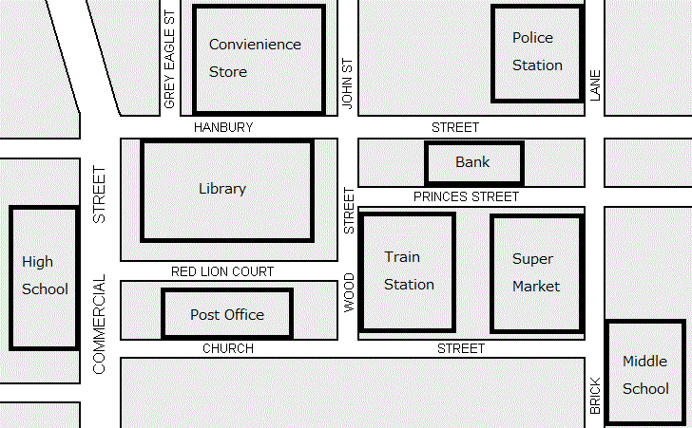

- The Library is across from the Convenience Store on the left
- The Middle School is on the opposite side from the High School
- The Bank is near the Train Station
- The Post Office is near the Library, but is not near the Supermarket
- The High School is on the Left
- The Train Station is lower than the Bank
- The Convenience Store and Police Station are at the top
- The Supermarket is near the Middle School

LIBRARY POLICE STATION HIGH SCHOOL

POST OFFICE CONVENIENCE STORE SUPERMARKET

MIDDLE SCHOOL TRAIN STATION BANK

