Name: _________________ Class: _____ Number: _____

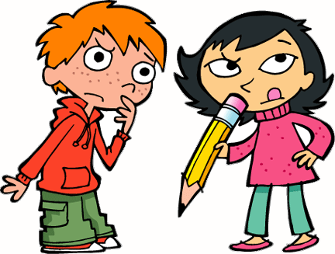
例: ( ___ is a place / It is visited by many _____. )
Kyoto is a place visited by many students.
We went there last winter.
- (I have a _____. It was made by ____.)
_________________________________________________________
_________________________________________________________
- (I’ve eaten ____. It was made with _____.)
_________________________________________________________
_________________________________________________________
- (I have a _____. It was made in _____.)
_________________________________________________________
_________________________________________________________
- (There are many _____. They are seen in ______.)
_________________________________________________________
_________________________________________________________
- ( ______ is an object. It is used by _____.)
_________________________________________________________
_________________________________________________________
- ( _____ is a TV program. It is watched on ______.)
_________________________________________________________
- (There are many _______. They are made by ________.)
_________________________________________________________
_________________________________________________________
- (I saw a _______. It was made by ________.)
_________________________________________________________
_________________________________________________________
- (I like many ______. They were made by ________.)
_________________________________________________________
_________________________________________________________
- (I like many _______. They are sung by ________.)
_________________________________________________________
_________________________________________________________
- ( _______ is a nice place. It is visited in ________.)
_________________________________________________________
_________________________________________________________
- ( _______ are cute animals. They are seen in ________.)
_________________________________________________________
_________________________________________________________
- ( _______ is a useful item. It is used to ________.)
_________________________________________________________
_________________________________________________________

