Name: ______________________

Please write a word for each number

- Famous person’s name: ____________
Famous Person = 有名人
Noun = 名詞
Place = 場所
Adjective = 形容詞
Emotion = 感情

- Noun: _____________________
(3) Noun: _____________________
(4) Place or country: ___________
(5) Game or sport: _____________
(6) Friend’s name: _____________
(7) Number: __________________
(8) Adjective: _________________
(9) Noun: ____________________
(10) Emotion: _________________

Name: ___________________

If I met (1)__________.

If I were (1)___________ I would buy lots of (2)_______(s). I love (2)__________(s).
If I knew (1)__________, I would ask him/her to buy me (a/an) (3)_________.
I wish we could travel together to (4)__________ and play (5)___________.

(6)__________ told me that he/she met (1) ________ (7)________ years ago. (6)_________ said that (1)__________ is very (8)_________.
(6) _________ said he/she was surprised that (1)_________ was afraid of (9)_______(s).
(1)________ always makes people (10)_________. I really hope I can meet (1)________ someday.

Rewrite your story:
____________________________________________________________________________________________________________________________________________________________________________________________________________________________________________________________________________________________________________________________________________________________________________________________________________________________________________________________________________________________________________________________________________________________________________________________________________________________________________________________________________________________________________________________________________________________________________________________________________________________________________________________________________________________________________________________________________________________________________________________________________________________________________________________________________________________________________________________________________________________________________________

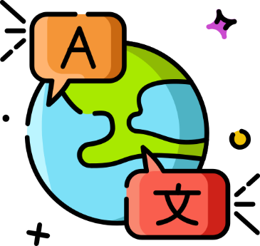

Translate your story to Japanese:
____________________________________________________________________________________________________________________________________________________________________________________________________________________________________________________________________________________________________________________________________________________________________________________________________________________________________________________________________________________________________________________________________________________________________________________________________________________________________________________________________________________________________________________________________________________________________________________________________________________________________________________________________________________________________________________________________________________________________________________________________________________________________________________________________________________________________________________________________________________________________________________

If I met (1)__________.

If I were (1) famous person (name) (1)___________ I would buy lots of (2) noun (2)_______(s). I love (2)__________(s).
If I knew (1)__________, I would ask (1)________ to buy me (a/an) (3) (noun) (3)_________. I wish we could travel together to (4) country (4)________ and play (5) game (5)_________.

(6) name of a friend (6)_________ told me that he/she met (1) ________ (7) number (7)_______ years ago. He/she said that (1)________ is very (8) adjective (8)_________.
(6) _________ said, he/she was surprised that (1)_________ was afraid of (9) noun (9)_________.
(1)________ always makes people (10) emotion (10)_________. I really hope I can meet (1)________ someday.

