Let’s talk about them
Name: __________________
Round One
This is ________________.  This is _____ hat.  He is a good ______er.  I like ________. | 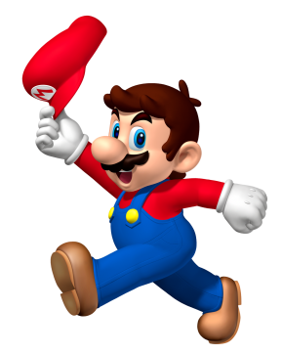
Round Two
This is ________________.  This is ____ flower.  She is _____________.  I ________________. | 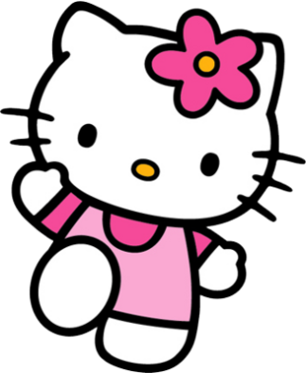
Round Three
_________________________________.  This is ____________________________.  _________________________________.  _________________________________. | 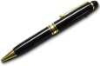  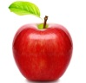  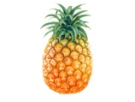  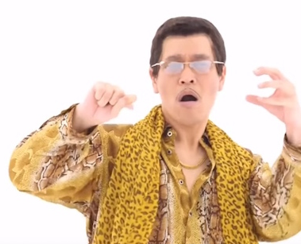
Round Four
________________________________.  This is __________________________.  ________________________________.  ________________________________. | 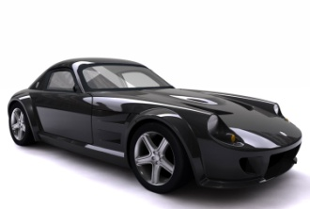  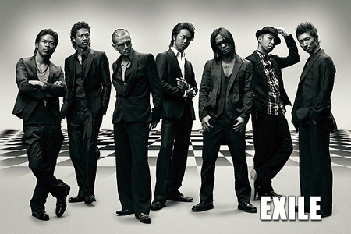
Round Five (you)
I am __________________________.
_____________________________.
_____________________________.
_____________________________.

Round Six (Friend, family, character or famous person)
________________________________.
________________________________.
________________________________.
_______________________________.

Good Job!

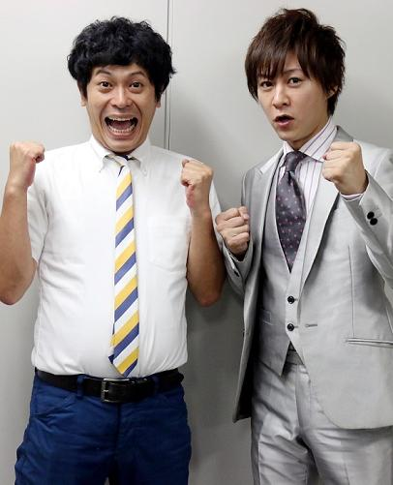

They are____________.

They are ___ neckties.

They are ___________.

I ___________.
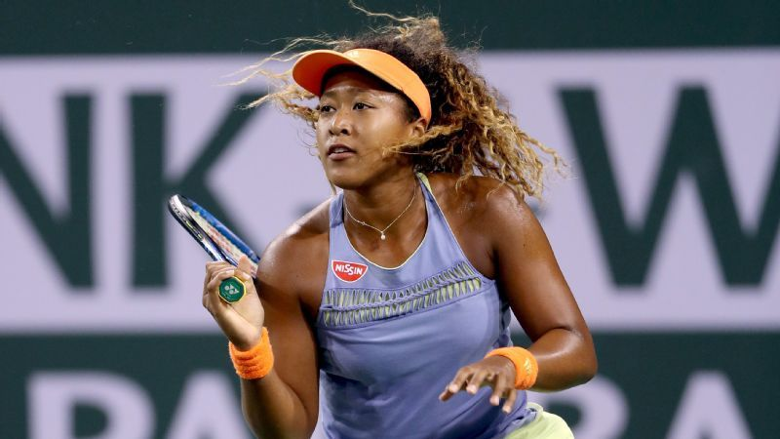

She is ___________________

This is ___ _______________

She is ___________________

I like _____. / I don’t like ____.

