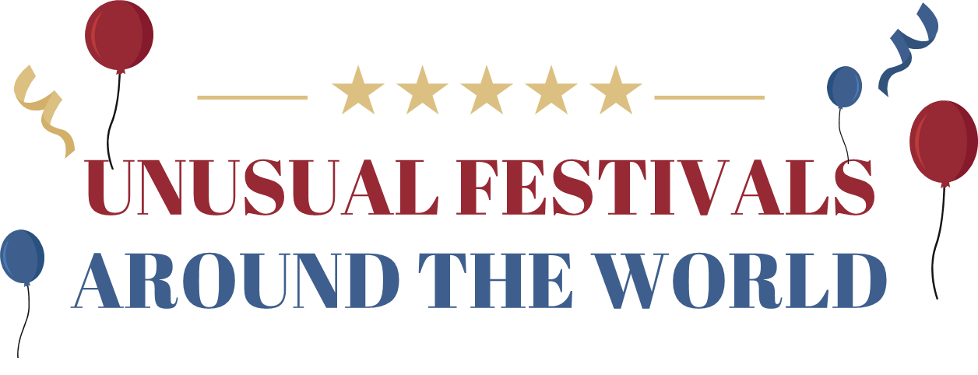
- This is a rolling festival. People roll _____________ down the hill!
The festival is from _____________.
It is called __________________________.
- This a jumping festival. People jump over _____________!
The festival is from _____________.
It is called __________________________.
- This is an obstacle track race festival. Men carry their _____________! The festival is from _____________.
It is called __________________________.
- This is a food festival. _____________ eat all the fruit!
The festival is from _____________.
It is called __________________________.
- This is a running festival. People run away from _____________!
The festival is from _____________.
It is called __________________________.
- This is a wrestling festival. People do _____________ wrestling!
The festival is from _____________.
It is called __________________________.
- This is a food fight festival. People throw _____________!
The festival is from _____________.
It is called __________________________.
- This is another food fight festival. People throw _____________!
The festival is from _____________.
It is called __________________________.
- This is a water festival, but there are many pigs. People _____________ the pigs!
The festival is from _____________.
It is called __________________________.
I got __________ points out of 27.
Your Turn!
Please tell me about festivals in Japan!
