Do you like…  __________________? | Do you watch…  __________________? | Do you read…  ____________________? | Do you cook…  __________________?
Do you know how to make…  __________________? | Do you clean  __________________? | Do you know how to use…  ____________________? | Do you listen to…  __________________?
Do you play…  __________________? | Do you drink…  _________________? | Do you speak…  ___________________? | Do you do your…  __________________?
Do you live in…  ___________________? | Do you go to…  __________________? | Do you help your…  ____________________? | Do you want…  ___________________?
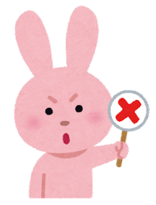
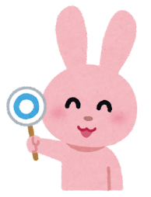
“Do you…” Bingo!
No, I don’t!
Yes I do!

