

TELEPHONE TALKS

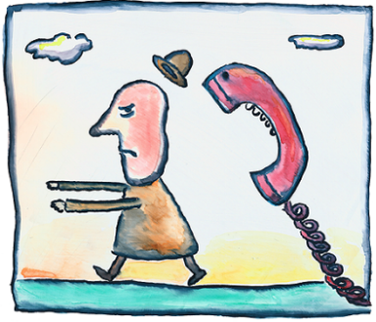**NUMBER ONE**

B: Hello.

A: Hello this is . May I speak to _____?

B: I’m afraid ___ isn’t home now.

A: I see. Could you give a message, please?

B: Of course. What is it?

A: Tell

B: I see. I’ll tell .

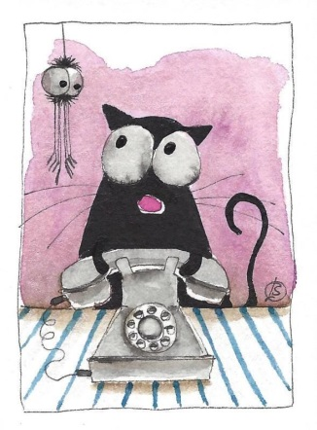A: Thank you.

**NUMBER TWO**

B: Hello.

A: Hello this is . May I speak to ______?

B: I’m afraid ____ isn’t home now.

A: I see. Could you give a message, please?

B: Of course. What is it?

A: Tell

B: I see. I’ll tell .

A: Thank you.

**NUMBER THREE**

B: Hello.

A: Hello this is . May I speak to ______?

B: I’m afraid ____ isn’t home now.

A: I see. Could you give a message, please?

B: Of course. What is it?

A: Tell

B: I see. I’ll tell .

A: Thank you.

**NUMBER FOUR**

B: Hello.

A: Hello this is . May I speak to ______?

B: I’m afraid ____ isn’t home now.

A: I see. Could you give a message, please?

B: Of course. What is it?

A: Tell

B: I see. I’ll tell .

A: Thank you.

B: Hello.

A: Hello this is Robert. May I speak to Mr. Smith?

B: I’m afraid he isn’t home now.

A: I see. Could you give him a message, please?

B: Of course. What is it?

A: Tell him I can’t go to the restaurant tonight.

B: I see. I’ll tell him.

A: Thank you.