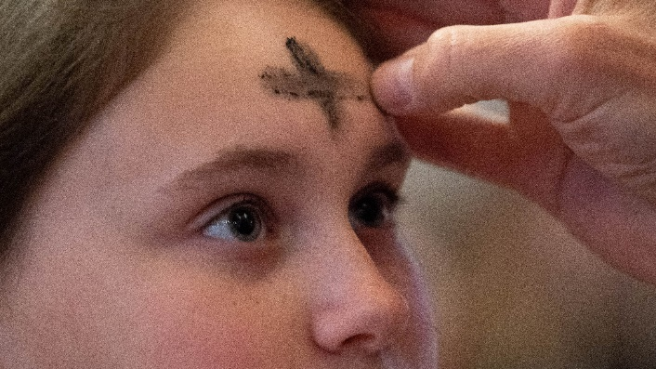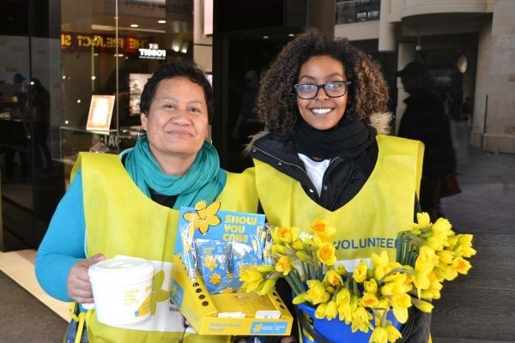

During Earth hour, we turn off the lights for one hour. What can you do to save electricity? m

Ash Wednesday is the first day of Lent.mmm Christians celebrate Lent by reflecting and fasting. mm

Daffodil Day started in the 1950s.

Cancer groups used this flower as a symbol of hope. Volunteers sell daffodils to support people with cancer all around the world.

Daffodil Clip Art Free - Cliparts. | Flower clipart, Spring flowers,  Daffodil flowerDaffodil Clip Art Free - Cliparts. | Flower clipart, Spring flowers,  Daffodil flower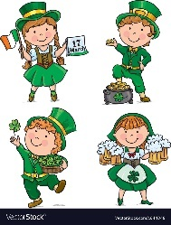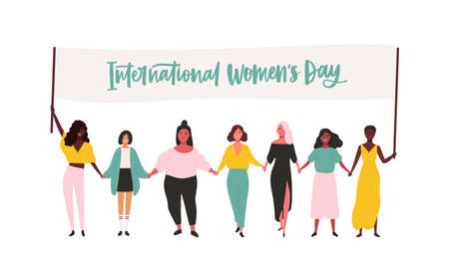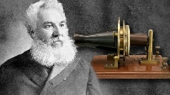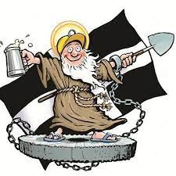

Day

Women`s

Saving

Daylight

Eiffel Tower Day

Earth Hour

Daffodil Day

St. Patrick`s Day

First Telephone

St. Piren`s Day

Spring Equinox

Mardi Gras

Ash Wednesday