Happy New Year!
2023 is the year of the rabbit!
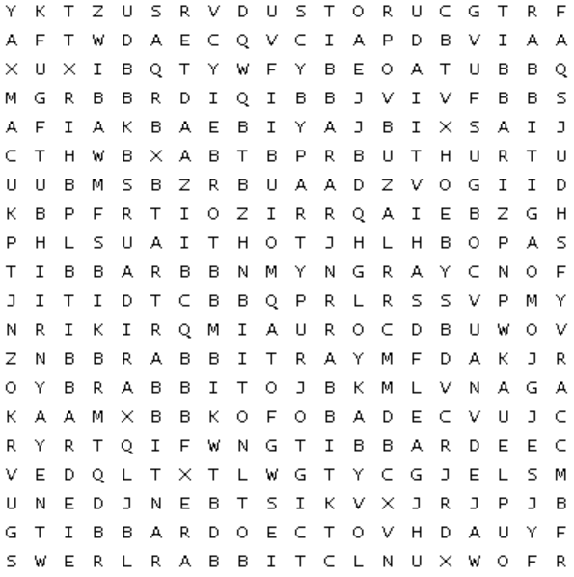
Can you find the word rabbit 23 times?
rabbitという単語を２３個見つけることができますか?

