Guess Who I am!

Q: If you have time, will you……..? (3 回まで質問OK)
A: Yes, I will. / No, I won’t. <x3>
Q:Are you (人物名)?
A: Yes, I am. / No, I`m not.
Will you ……. => | do your homework tonight | clean your room this weekend | help your family on Sunday | study English hard every day | Friends` name
Beat Takeshi | O | X | O | X
Matsuko Deluxe | X | O | X | O
Mario | O | X | X | O
Jaiko  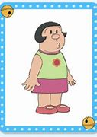 | O | O | X | X
Elsa | X | X | O | O
Darth Vader | X | O | O | X

Name: Class - ( ) Date:

