Unit 5: Let’s make a 3 hint quiz!

Hint 1: Where do you live?

I live in the __________________________.

Hint 2: What do you eat?

I eat _______________________________.

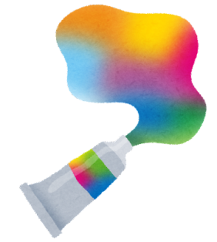
Hint 3: What color are you?

I am _______________________________.

What animal are you?
I’m a ________________________.

