****1. Would you sign your name for me?

Name: _________________ Class: ____ Number: ___

Yes, I’d love to.



2. Would you draw a __________ for me?

Yes, certainly



3. Would you write a __________ for me?

Sure, you bet.

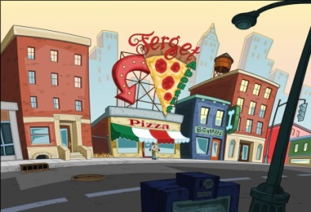

Clerk: May I help you?

Customer: Yes, I’d like a pizza.

Clerk: Great, we have vegetarian and meat lovers?

Customer: I’d like meat lovers please.

Clerk: All right, anything else?

Customer: Yes, please. Would you put extra cheese on it for me?

Clerk: Certainly.

***Pizza***

***Shop***

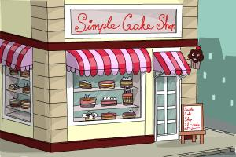Cake Shop

Clerk: May I help you?

Customer: Yes, I’d like a _____________.

Clerk: Great, we have _______________ and __________________?

Customer: I’d like _________________ please.

Clerk: Alright, anything else?

Customer: Yes, please. Would you ____________________________?

Clerk: Certainly

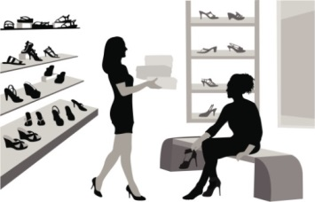Shoe Store

Clerk: May I help you?

Customer: Yes, I’d like new _____________.

Clerk: Great, we have _______________ and _________________?

Customer: I’d like _________________ please.

Clerk: Alright, anything else?

Customer: Yes, please, would you ____________________________?

Clerk: Certainly.

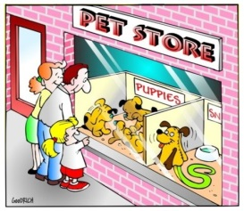Pet Shop

Clerk: May I help you?

Customer: Yes, I’d like a new ______________.

Clerk: Great, we have ______________ and __________________?

Customer: I’d like _________________ please.

Clerk: Alright, anything else?

Customer: Yes, please, would you ____________________________?

Clerk: Certainly.