Name:

START / FREE | living in Tokyo | watching TV | playing tennis | growing vegetables | learning Chinese
playing the guitar | I have been living in Tokyo since last year.  ☞ (1point)  BONUS points:  - Pass START ☞ 2 points  - Predict (予測する) ☞ 1 point  1 – since last year 2 – since yesterday  3 – since 2016 4 – for two years  5 – for a long time 6 – for an hour |  |  |  | making cakes
using this pencil |  |  |  |  | playing the piano
playing rugby | 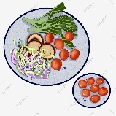  eating vegetarian food | collecting stamps | teaching English | taking pictures | painting

SCORE CARD:

