Train Station Destination Help
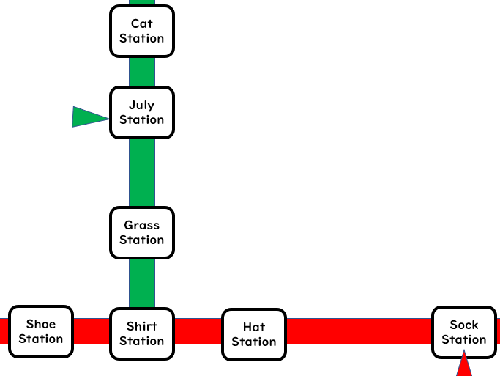
Situation: A tourist wants to get to a station on a different line.
「Sure!」
「Could you tell me how to get to July Station?」
2: Take the _______ line. ______ Station is ____ stop(s) from ______ Station.
1: Take the _____ line to _____ station, and c _ _ _ _ e trains there.
Start
Green Line
Red Line

Train Station Destination Help
Situation: A tourist wants to get to a station on a different line.
「Sure!」
「Could you tell me how to get to July Station?」

2: Take the _______ line. ______ Station is ____ stop(s) from ______ Station.
1: Take the _____ line to _____ station, and c _ _ _ _ e trains there.
Start
Green Line
Red Line

Train Station Destination Help
Situation: A tourist wants to get to a station on a different line.
「Sure!」
「Could you tell me how to get to July Station?」

2: Take the _______ line. ______ Station is ____ stop(s) from ______ Station.
1: Take the _____ line to _____ station, and c _ _ _ _ e trains there.
Start
Green Line
Red Line

Train Station Destination Help
Situation: A tourist wants to get to a station on a different line.
「Sure!」
「Could you tell me how to get to July Station?」

2: Take the _______ line. ______ Station is ____ stop(s) from ______ Station.
1: Take the _____ line to _____ station, and c _ _ _ _ e trains there.
Start
Green Line
Red Line

