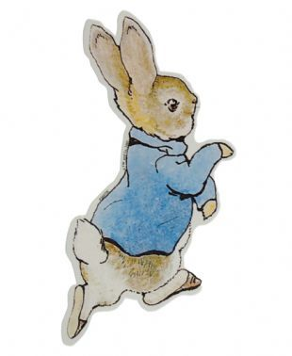
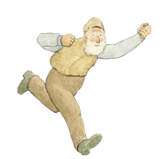
Name: ___________ Class: _____ Number: ______
RABBIT IN
THE GARDEN
- Who lived with Peter Rabbit?
_________________________________________
_________________________________________
- What did Peter’s mother say?
_________________________________________
_________________________________________
- Did Peter listen to his mother?
_________________________________________
_________________________________________
- Who did Peter see when he was looking for parsley?
_________________________________________
_________________________________________
- What did Peter’s mother do when Peter arrived at home?
_________________________________________
_________________________________________
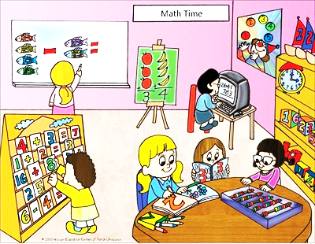
- What were they doing at 2:00?
Susan
Lisa
_________________________
_________________________
Mary
_________________________
_________________________
Jenny
- What were you doing at 9:00 last night?
_________________________________________
_________________________________________
- If it’s rainy, lets…
_________________________________________
_________________________________________
- If we have a big test, let’s…
_________________________________________
_________________________________________
- How can I get to Harbor Land?
__________________________
__________________________
__________________________
__________________________
- What did Paul do on March 27th? (page 8)
_________________________________________
_________________________________________
_________________________________________
- Where was Mickey? What was he doing? How was it?
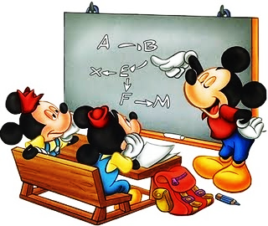
_____________________________
_____________________________
_____________________________

- If it’s sunny, let’s…
_________________________________________
_________________________________________
- What season do you like? Why do you like it?
_________________________________________
_________________________________________
TEAM: ____________
1 | 2 | 3 | 4 | 5 | 6 | 7
8 | 9 | 10 | 11 | 12 | 13 | 14
TEAM: ____________
1 | 2 | 3 | 4 | 5 | 6 | 7
8 | 9 | 10 | 11 | 12 | 13 | 14

TEAM: ____________
1 | 2 | 3 | 4 | 5 | 6 | 7
8 | 9 | 10 | 11 | 12 | 13 | 14

TEAM: ____________
1 | 2 | 3 | 4 | 5 | 6 | 7
8 | 9 | 10 | 11 | 12 | 13 | 14

TEAM: ____________
1 | 2 | 3 | 4 | 5 | 6 | 7
8 | 9 | 10 | 11 | 12 | 13 | 14

